1. Convert to a pbi
2. Open visual studio
3. Change VS code to be trusted window if not
4. Download Git for Windows

Using Git with Visual Studio Code

<https://www.youtube.com/watch?v=i_23KUAEtUM>

<https://docs.github.com/en/get-started/quickstart/set-up-git>

1. Download the latest version of Git
2. Set your username and commit email address

Configuring within Git

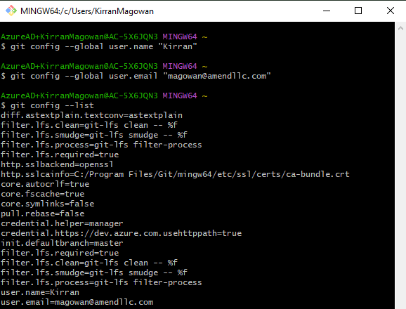

Configuring your changes to the repo

1. Either stage or leave them all unstages